Professor K.Michael
Silvia Duran

My research paper is on crime in the Bronx. New York City consists of five administered divisions called boroughs, The Bronx, Brooklyn, Manhattan, Queens and Staten Island. The Bronx has always been known as one of the worse, poorest and crime ridden borough. According to the US census bureau the south Bronx is the poorest district in the nation. 38% of residents live below the poverty line. Hunts Point ranked 67 out of the 69 neighborhoods for crime. There were 135 violent crimes per 100,000 residents, enough to put the neighborhood dead last in the category. There were also increases in rape (up 67 percent), misdemeanor sex crimes (26 percent) and robberies (26 percent). Although the Bronx is on the worse neighborhoods’ lists, having extra funding would greatly benefit.
According to neighborhoodcout.com the chances of becoming a victim of a violent crime in the Bronx are 1 in 102, and 1 in 208 in NYC. For Bronx, we found that the violent crime rate is one of the highest in the nation, across communities of all sizes (both large and small). Violent offenses tracked included rape, murder and non-negligent manslaughter, armed robbery, and aggravated assault, including assault with a deadly weapon. Nyc.gov explains how in the summer of 2017, the Mayor's Office to Prevent Gun Violence is inviting applications from New Yorkers for small grants, ranging from $500 to $1000, to incentivize and encourage resident leaders and organizations to promote peace in communities across the city. Proposals should be creative and specific, encourage community cohesion and empowerment and be geared toward violence reduction and promotion of positive lifestyle choices. It’s not like the money will be falling from the sky. Applicants have to be able to demonstrate they can make an impact — whether that’s with data, or evidence of your own community engagement skills.

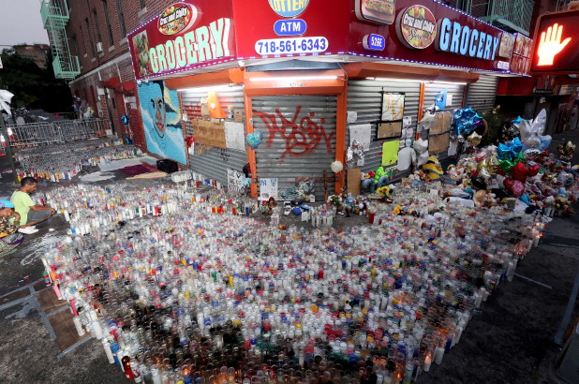
This is the image that has been seen all around the country. It is the last place where a 15-year-old Bronx native Lesandro “Junior” Guzman-Feliz was brutally stabbed to death just a few blocks from his own home and also a few steps away from Saint Barnabus Hospital. Members of the Trinitarios gang were hunting for enemies in the Bronx last summer when they found a 15-year-old boy on his phone and walking alone. Mistaking him for a member of a rival set, the gang chased the boy, Lesandro Guzman-Feliz, for blocks in the Belmont section of the Bronx, prosecutors said. The desperate teenager tried to hide inside of a bodega, but the gang members dragged him from the store and stabbed him to death as security cameras recorded the gruesome scene. As of October 2019, According to ABC7 News Twenty-five-year-old Antonio Rodriguez Hernandez Santiago, 23-year-old Jose Muniz, and 25-year-old Elvin Garcia were all sentenced to 25 years to life, while 19-year-old Manuel Rivera was sentenced to 23 years to life because of his age at the time of the crime. Surveillance video from a Bathgate Avenue bodega showed some of them dragging Junior out into the street where he was stabbed to death, only about a block away from his apartment.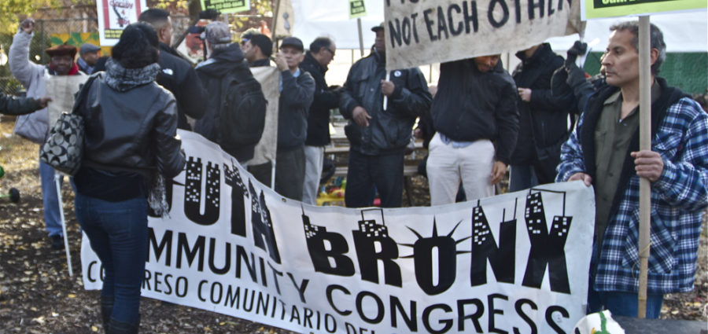
This image shows a protest to stop violence in the Bronx. Violence has climbed steadily, almost straight up, since 2008. This year’s toll, both overall, and individually for murder, rape and assault , is the highest in at least five years. The count so far is at least 20 murders and 23 rapes; that’s about one of every two weeks, in a population of less than 180,000. Banners at the residents’ march against violence primarily demanded more jobs and less poverty, as a solution to the spike in violence. “It’s all about connecting the dots between our social problems and violence,” said Raymond Figueroa, who runs a development program for incarcerated youth at Brook Park. Joblessness feeds poverty in our community,” reiterated Figueroa, “which in turn makes it difficult for our kids to stick to school.” The 2006 Community Health Profiles estimate the poverty level in Mott Haven at 45 percent, twice as much as New York City overall.

“Poor school-age kids eventually turn to friends on the street for support, and that’s how they become gangs. The Dominicans go to the Trinitarios, the African Americans stick with the Bloods, the Puerto Ricans with the Latin Kings, and so on.”
In conclusion, poorer neighborhoods have more youth dropping out of school, who then turn to crime or violence. If neighborhoods had more funding, we could provide better school for our youth to get a better education. More after school activities, police surveillance, security or security cameras. Also could bring more business which in turn can bring more jobs to the poor neighborhoods so that people wouldn’t turn to crime. Investments that increase inclusion and support education, skills, and access to jobs may be necessary to address the concentrated disadvantage at the root of violent crime in neighborhoods. Programs could also prevent violent crime by helping youth and others avoid violence. Businesses close early for fear of being victims of a crime, residents do not shop late for the same reason, with police presence this could be changed and in turn bring more revenue to the neighborhoods that need it most. The best strategies for fighting crime in residential neighborhoods are those where the police work closely with resident organizations. Such community-based strategies require residents to believe that others in their neighborhood are committed to a crime-free environment. Then they will be more willing to take part in public or private anti-crime programs, and be mobilized by police forces.

