Christina Ayala
Professor Michael
English 110-216B
12/11/19

MTA DISPUTES

My map is about the MTA Transit Services in NYC, and how it lacks to have most stations accessible to those who truly are in need of it. A number of NYC residents feels that they are not being herd or are being ignored by the MTA New York City Transit Services. On how a lot of stations are inaccessible to them. But who really cares? Who besides me and a wide spread of people in NYC who are either disable, an elder, or even a simple mother who carries with a stroller has a take in these claims? At the very least, these people who formerly believed that the MTA NYC Transit Services should be more accessible should care. The MTA NYC Transit Services said there will be updates it hasn’t been done. The reason is because there is not enough elevators for the women have babies or disable no matter what type of disability. People in need of elevators should be able to get to the platforms or the streets. Although the buses are more accessible it doesn’t always take you were the trains can. The MTA New York City Transit Services is a lifelong benefit even though there are a lot of upgrading to do.
The MTA New York City Transit Services should make more stations accessible. In February 2019, writer Patel, Jugal k. published “Where the subway Limits New Yorkers with Disabilities” on the New York Times. Which summarizes what’s going on and how it’s affecting people who need accessible stations. Also how inaccessible stations can even become life threatening. Patel states “The subway is tightly woven into the daily routine of many New Yorkers, but it remains largely inaccessible or dangerous to hundreds of thousands of people throughout the city.”(Patel, Feb 2019). Patel is surly right about the dangers of inaccessible stations to New Yorkers, because as people may not be aware, recent studies and complaints have shown that it is becoming a problem. The Statement shows that this stations can cause more issues that this station can cause more issues that need to be known. Us as the people want to see improvements.
The MTA New York City Transit Services should make more stations accessible. Alexa, Alexandra’s article, “NYC Has Fewer Accessible Subway Stations than MTA Claims, Report Says”, sum up on the low amount of stations that are inaccessible and how it becomes a problem for New Yorkers. Also on how the MTA has not kept up to date with updating the stations. Alexa states “The Metropolitan Transportation Authority currently claims that 144 of its 427 stations-or-24 percent-are accessible.”(Alexa, February 2019). Those unfamiliar with her statement may be interested to know that it basically boils down to the concerns about the MTA and how they keep things running. As well as the stations being accessible and maintaining them, for the New Yorkers who spend money and trust the MTA to be able to get them where they need to go safely. Although MTA posts on how they make updates, I agree with Alexa on how you can see in person how it hasn’t. And yet the MTA stations that are still inaccessible become dangerous.
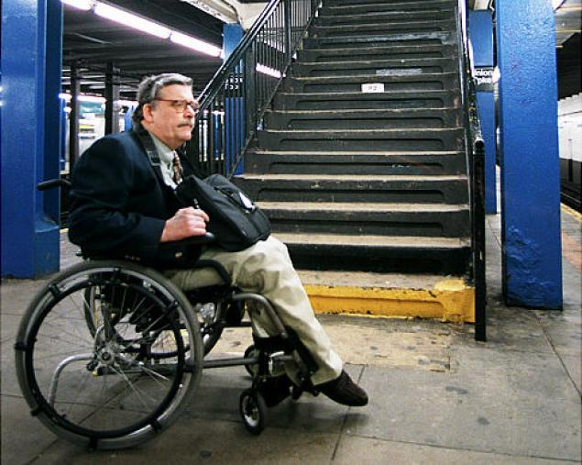
Figure 1 : Union Turnpike Station

The MTA NYC Transit Services should, make more stations accessible. In March 2019, CBS’s New York reporter Jessica Moore published a video on YouTube called “Rally for More Subway Elevators”. This video summarizes how dangerous and life threatening train stations that are inaccessible can be. Also is presents on a women who died because she fell down the stairs carrying her stroller in the station. Jessica reports “And the problem is pervasive of the 472 Subway Stations in NYC the MTA says only 120 are currently equipped with elevators, this afternoon n at the carnage hall station we saw women struggling with strollers and a father help his handicapped son navigate the steep stairs”.(Moore, March 2019). Those unfamiliar with this broadcast happening may be interested to know that this is not the only incident like this happening. Issues like this happen way more than it should which is very devastating. Although people are getting responses on how it’s getting taken care of I still see people struggling without getting help.
Nevertheless, The MTA New York City Transit Services will probably suggest otherwise and argue that the MTA Services will be installing elevators and that they keep stations in good conditions. Also say that they are aware of all the complaints over the years. My Map will be showing all the lines and stations of the New York City MTA Transit Services. It will show all the stations that are inaccessible (circled stations). Through my personal experience with the MTA I have seen a lot of disable people struggle or even ask me for directions to where there is a station that is accessible. I even seen single parents struggle with strollers or that their kids are disable and needs to help them. I have even struggle having to carry my niece when she was a baby and carrying the stroller as well, a nice man helped me.

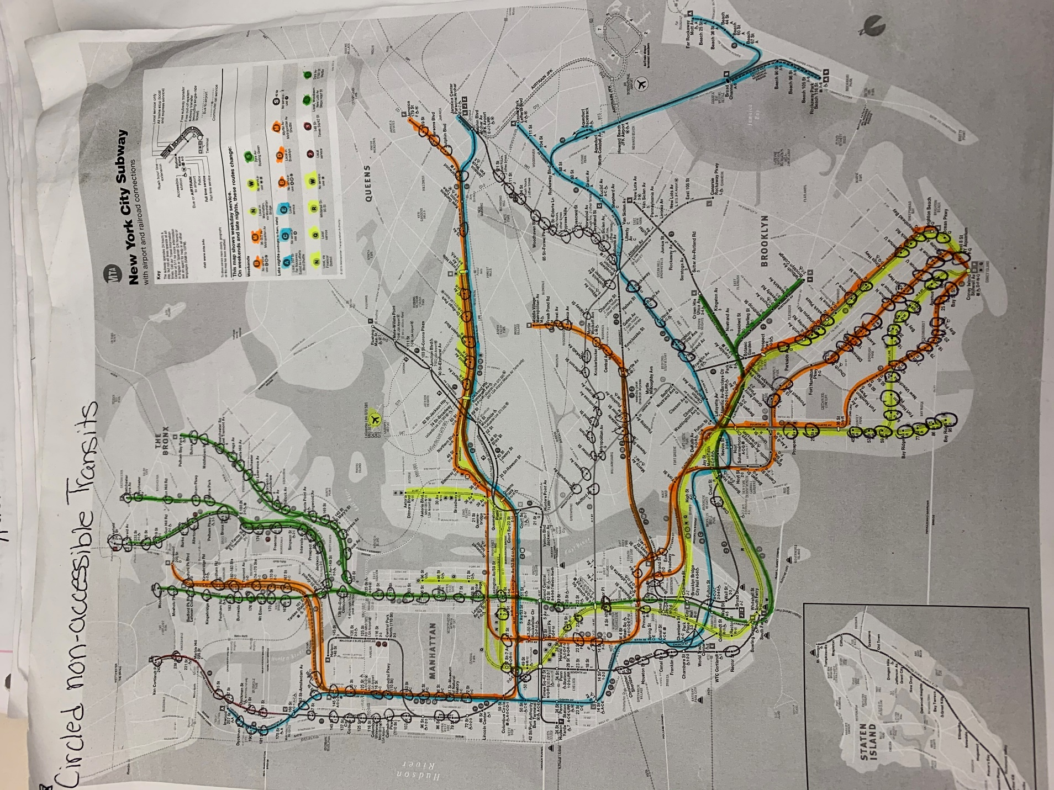

Works Cited
Alexa, Alexandra. “NYC Has Fewer Accessible Subway Stations than MTA Claims, Report Says.” 6sqft, 6 Feb. 2019, https://www.6sqft.com/nyc-has-fewer-accessible-subway-stations-than-mta-claims-report-says/.Patel, Jugal K. “Where the

Subway Limits New Yorkers With Disabilities.” The New York Times, The New York Times, 11 Feb. 2019, https://www.nytimes.com/interactive/2019/02/11/nyregion/nyc-subway-access.html.

