Keury Galan
English 110
Section 216B

Racially Diverse yet Racially Divided: The truth about New York City

New York City is and always has been clearly divided. Five different boroughs host all kinds of people from all walks of life. Certain neighborhoods ` have social and economic disadvantages compared to others. This map highlights different parts of the cities and how it’s racially concentrated in certain areas. It will also reveal how some low-income areas are mainly populated with minorities. It is vital to understand the differences within ethnicities, especially in a city that wants to promote diversity. It is important to bring awareness to these issues in order to create solutions and promote equality. Although New York City is racially diverse and enriched with different cultures, citizens can still experience a sense of racism and socioeconomic division, which indicates that New York City is not racially equitable. 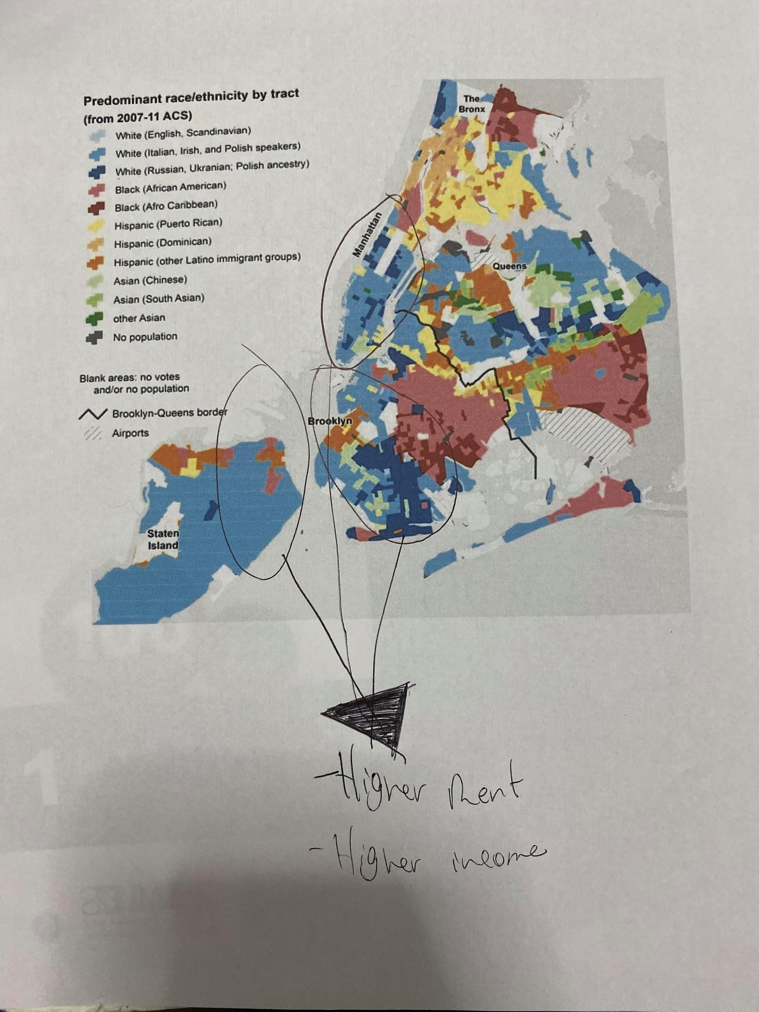
New York City is an immense city known for being racially and culturally diverse. Settled by people all from around the world, the city is home to nearly 20 million souls. The city of New York has many different cultural areas built by immigrants from all around the world. One clear example of this is famous neighborhoods like Koreatown, Little Italy or Harlem. A video-documentary titled “Many people from the same parts of the world gathered together in distinct parts of the city. It was in this way that places like Koreatown was formed. ” Similar distinct neighborhoods around the city, such as Harlem, and Washington Heights were built just the same as this. An article written by Paul McGinniss for the Great American Country states. “A recent U.S. Census Bureau report about NYC revealed an increasingly diverse and dynamic city with immigrants making up the majority of the residents in some neighborhood.” The author highlights perfectly how different cultures and communities blend together to create a vibrant experience for residents and visitors alike. There is an incentive to explore each part of the city and get a taste of what they have to offer. However, diversity does not necessarily suggest equality.

The people of New York experiece racism and are affected by a racist law system. As a result, there are social and economic differences between ethnicities. Echoes of racism still ring in the vibrancy of the city. An article was written by Bob McManus of the New York Times, states “There was a 5.7 percent unemployment rate among African-Americans with a bachelor’s degree or higher in 2013, compared with 3.5 percent among white Americans with a bachelor’s degree or higher. Indeed, joblessness is higher among blacks in every education level tracked by the Labor Department.” The author is informing about the economics and pay gaps between races. Black people have a higher rate of unemployment and on average make less than their white counterparts. The same can easily be said for other minorities in the city. This shows that although New York City is racially diverse overall, racism and socioeconomic inequality is still evident in American society. This significantly affects the social climate and racial balance in the city.

Much like anywhere else in the United States, New York City is not racially balanced. It is full of racism and other kinds of racial division. A clear example of this can be shown in New York City’s schooling system. Schools in the city are commonly segregated, communities stay within the school districts surrounding them, unwilling or unable to receive different qualities of education. A film by Jim Epstein about Brooklyn’s schooling system shows how ps8 district students are not minorities and had no economic disadvantage, therefore this school district has higher standards of education equality. As for 307 districts, its students are commonly minorities and they get a lower quality of education. This clearly shows how the school system is segregated and it reflects how the city is not racially balanced. Minorities and people of lower classes are almost never given opportunities to receive a better education. It is important for New Yorkers to be aware of this problem so we as a society can get out of this together. An article written by Bob McManus in the New York Post says “The chancellor threw down the race gauntlet from Day One. He picked fights with white parents, promised to achieve racial balance in the city’s selective high schools and commissioned a $23 million “implicit-bias” social-conditioning regimen that lies at the heart of the former administrators’ $80 million lawsuits.” This piece of evidence clearly shows attempts by authorities to restrain racism and racial inequality as much as possible. It is extremely valuable to desegregate the schooling system in the city of New York However, in order to keep the racial balance of the city.
Some might say that New York City is the most inclusive area in the United States. However, it has been proven that New York City is not racially balanced. Although the city is a melting pot of different cultures and ethnic backgrounds, minorities are still treated as less than. The map reflects how different races and ethnicities are concentrated in certain areas. Also, it shows how minorities, in general, are concentrated in low-income areas. This map also helps to support the idea of white people maintaining minorities in low-income areas because of adversities like raised rent. As a minority myself, I have experienced multiple types of racial segregation starting with the New York City schooling system. I live in Manhattan and I was assigned to a Bronx school district, in a school where nearly 98% of its students were Black, Hispanic and/or immigrants. Overall, New York City has a lot to work on in terms of racial equality and as a society, we need to use our voices to make a change.

1- McGinnissPaul .“Cultural Diversity In New York City”, Great American Country,2019https://www.greatamericancountry.com/places/local-life/waldoboro-maine-attractions-and-highlights

2- Erwin Neil. “America’s Racial Divide, Charted” , The New York Times, august 19, 2019
https://www.nytimes.com/2014/08/20/upshot/americas-racial-divide-charted.html
3- “Reason tv, Brownstone Brooklyn's Racial Divide: Why Are the Schools So Segregated?”,youtube, uploaded by Reason TV, january 26,2016 https://www.youtube.com/watch?v=yePxe4kKC5k

4-Bob McManus, New York Post, Racial Division is Richard Carranza’s only agenda, 2019
https://nypost.com/2019/06/04/racial-division-is-richard-carranzas-only-agenda/

5-“The Bronx in The 1980's PART 1”,youtube, uploaded by STBNY, march 28, 2010
https://www.youtube.com/watch?v=xgUsEVwXch0&t=416s

6-“New York: The city of many cultures”,youtube,uploaded by Jonathan D'Ambrosio, Going Global, , april 13,2013

https://www.youtube.com/watch?v=BWxm1GFWNsA

