Diana Marfo
Krystyna Michael
English 110-210B
10 December 2019
Childhood Obesity
Some might say that everyone is dying to be thin. I’m not sure how true that popular saying is because I always observe some level of obesity during my daily outings. The most troubling of my observation is when I see obese children. This is particularly concerning being that ailment in childhood can be carried into adulthood if it is not taken care of. Some illnesses linked to childhood obesity are type 11 diabetes, cardiac issues, respiratory issues, cholesterol and death due to coronary failure. These sicknesses in obese children stem from junk food, poor quality of foods and excessive eating. Childhood obesity is a problematic in low income areas affordability of quality food. Although junk food is less expensive and people can afford it, it is not good to consume. Therefore, the price of healthy food should be reduced so that low- income people can have access to healthier food choices.
According to the National Center for health statistics the number of obese children ranges from ages 6-19 have tripled to 16% over twelve years. The article also points out that one in six children suffers obesity, which has impacted on child physical and emotional health and children who are overweight have greater tendency to become obese throughout their adulthood. According to the research there are many ways a child can be obese example poor diet, lack of physical activities, stress, marketing, lunch options at school and boredom are all factors contributing to childhood obesity. Some might say that the Bronx is the most extensive area in the United States. However, it is not the only place with children that are obese.
Although the city is having a lot of bodegas and fast food restaurants all over the place people are still not thinking about their health but focusing on unhealthy foods. The map reflects on how in every one supermarket there are six bodegas around.
Also, it shows how obesity in general happens in low income areas. Also, this map is helpful because being obese leads to health problem and increase the chance of being diagnose with diabetes and it also proves that fast food is the main factor of obesity Additionally it shows how it is easier to buy fast food than prepare it. In my research what I found out was that this also contributes to childhood obesity, the presence of supermarkets and convenience stores like bodegas has a higher rate of contribution to childhood obesity which also leads to diabetes. The objects in this is to determine the awareness of food access through bodegas. That is to say that some people think is the easiest and convenient way for people to purchase food and have access to affordable and unhealthy foods products.
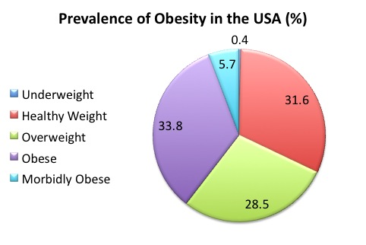

.

Physician- A person who is legally qualified, Obesity – the condition of being overweight
Bariatric- relating to treatments of obesity. This article ranges from 2004- 2019. As the time period becomes more presents. The articles show how childhood obesity rate has increase drastically and how more children are having to deal with Adult like illness i.e. type 2 diabetes and heart problems early on in life. This article provides ways and solutions into the world of how doctors, parents and schools can do to help not only decrease the rate but prevent it as well.

Lorna E. Thorpe, Deborah G. List, Terry Marx, Linda May, Steven DHelgeson, Thomas R. Frieden “Childhood Obesity in New York City Elementary School Students” American Journal of Public Health, vol. 94, no. 9, 2004, pp. 1496–1500.

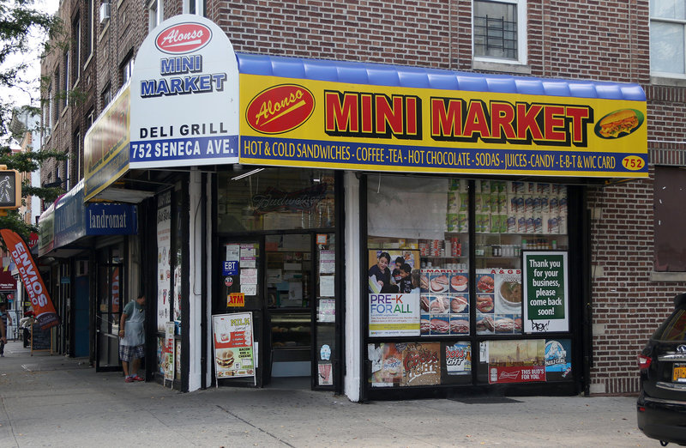
Alonso grocery store 20019, University Avenue Bronx. Web. Nov. 10, 2019. Castillo grocery store is one of the busiest and recognizable stores in my neighborhood that primarily sells food, they offer nonperishable foods that are packaged in bottles and boxes, which increase awareness of food access. In other words, it is easy and convenient for people to purchase food and having access to affordable and nutritious foods, which also contributes to the prevention of obesity.

Web. Nov 9, 2019
Condition of being overweight Bariatric- relating to treatments of obesity
This article ranges from 2004- 2019. As the time period becomes more presents. The articles show how childhood obesity rate has increase drastically and how more children are having to deal with Adult like illness i.e. type 2 diabetes and heart problems early on in life. This article provides ways and solutions into the world of how doctors, parents and schools can do to help not only decrease the rate but prevent it as well.
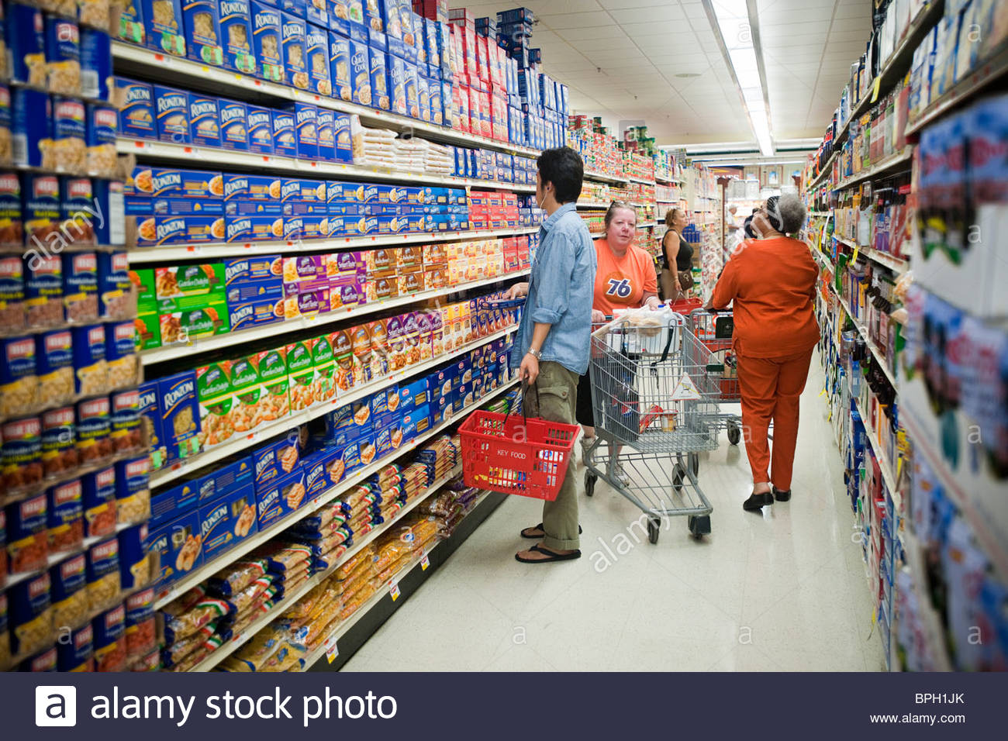
Castillo Supermarket (local bodega) is one of the busiest and recognizable stores in my neighborhood that primarily also sells food products which has a variety of food, beverages and household product which are organized into section and shelves and also household cleaners. In other words, all this store sells foods product that contributes to childhood obesity because some of the parents are so busy with their work so they don’t have time to cook for their kids and all they provide for their children is fast food and the kids get use to junk food.
Terry Mara MD, Lorna E. Thorpe, Linda May and Thomas R. The prognosis of obesity in Department of
Health and Mental hygiene web April 27, 2004.

Web Network Times Vole 158 Aug 16 2009. The American journal of public” say kids are fat” in other words poor diet in children has contributed too poorer eating of fruits and vegetables and have a higher intake of saturated fats. That is to say kids don’t focused on healthy foods rather likes eating unhealthy products, but how to prevent obese in children is parents needs to prepare nutritious and healthy food, improve dietary intake, and to reduce television which can also control overweight in children. According to the article obesity has a higher rate in Hispanic children usually in boys. That is to say that mostly obese kids are mainly associated with Spanish children.

